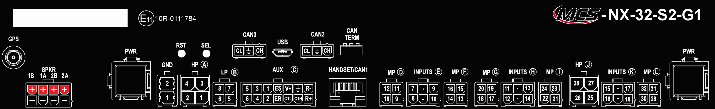
Conn. | Type | Nr. | Omschrijving | Max A
 | PWR |  |  | 70A
 | PWR |  |  | 70A
 | GND | 01
 | GND | 02
 | GPS
 | SPKR | 1A (+)
 | SPKR | 1A (-)
 | SPKR | 1B (+)
 | SPKR | 1B (-)
 | SPKR | 2A (+)
 | SPKR | 2A (-)
 | SPKR | 2B (+)
 | SPKR | 2B (-)
 | HANDSET/CAN1
 | CAN2 | CL
 | CAN2 | SHLD
 | CAN2 | CH
 | CAN3 | CL
 | CAN3 | SHLD
 | CAN3 | CH
A | HP | 01 |  | 20A
A | HP | 02 |  | 20A
A | HP | 03 |  | 20A
A | HP | 04 |  | 20A
B | LP | 05 |  | 2,4A
B | LP | 06 |  | 2,4A
B | LP | 07 |  | 2,4A
B | LP | 08 |  | 2,4A
C | AUX | 01
C | AUX | 02
C | AUX | 03
C | AUX | 04
C | AUX | 05
C | AUX | 06
C | AUX | ES
C | AUX | ER
C | AUX | V+
C | AUX | GND
C | AUX | C1L
C | AUX | C1H
C | AUX | R-
C | AUX | R+
D | MP | 09 |  | 8A
D | MP | 10 |  | 8A
D | MP | 11 |  | 8A
D | MP | 12 |  | 8A
E | INPUTS | 07
E | INPUTS | 08
E | INPUTS | 09
E | INPUTS | 10
F | MP | 13 |  | 8A
F | MP | 14 |  | 8A
F | MP | 15 |  | 8A
F | MP | 16 |  | 8A
G | MP | 17 |  | 8A
G | MP | 18 |  | 8A
G | MP | 19 |  | 8A
G | MP | 20 |  | 8A
H | INPUTS | 11
H | INPUTS | 12
H | INPUTS | 13
H | INPUTS | 14
I | MP | 21 |  | 8A
I | MP | 22 |  | 8A
I | MP | 23 |  | 8A
I | MP | 24 |  | 8A
J | HP | 25 |  | 20A
J | HP | 26 |  | 20A
J | HP | 27 |  | 20A
J | HP | 28 |  | 20A
K | INPUTS | 15
K | INPUTS | 16
K | INPUTS | 17
K | INPUTS | 18
L | MP | 29 |  | 8A
L | MP | 30 |  | 8A
L | MP | 31 |  | 8A
L | MP | 32 |  | 8A

